TASK 2

3. Student Information Retrival

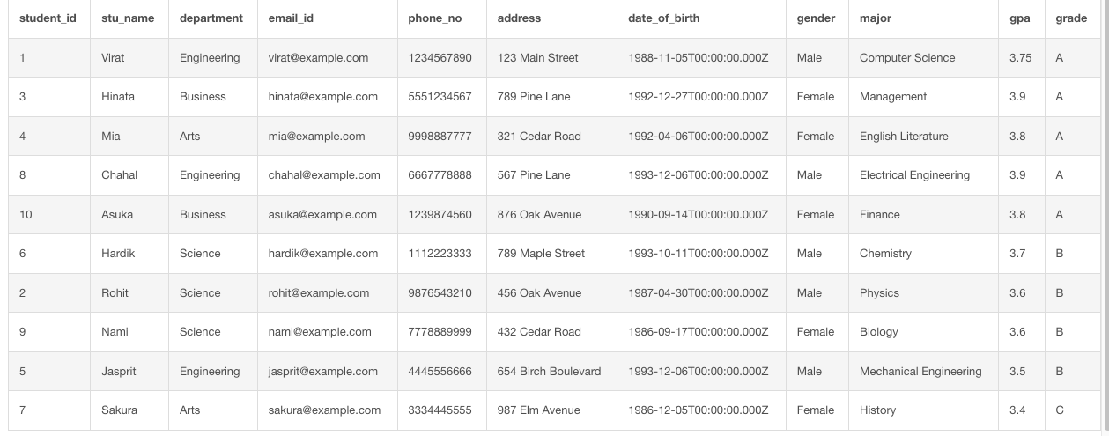

4. Query for Male Students

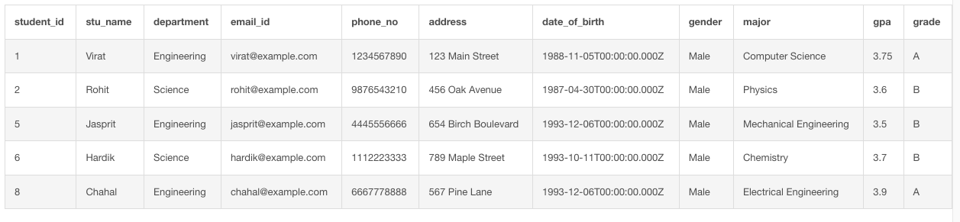

5. GPA < 5.0

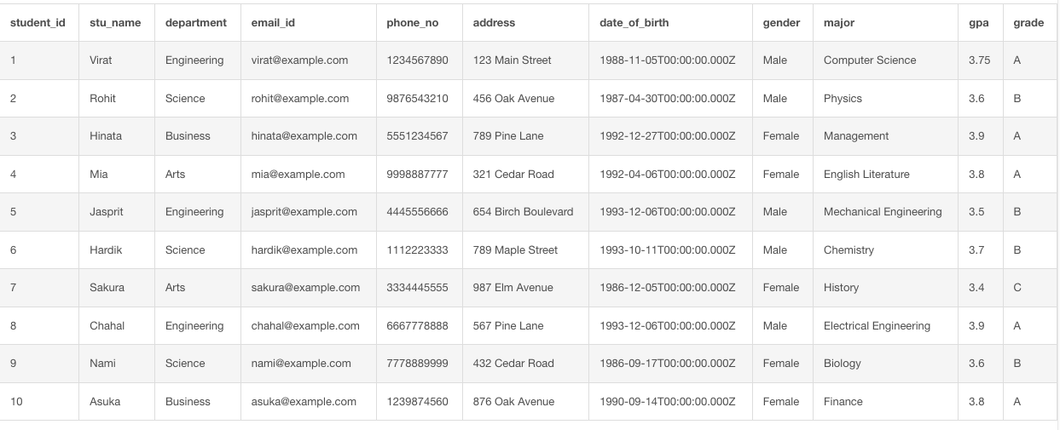

6. Update Student Email and Grade

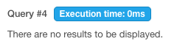

7. Query for students with grade B

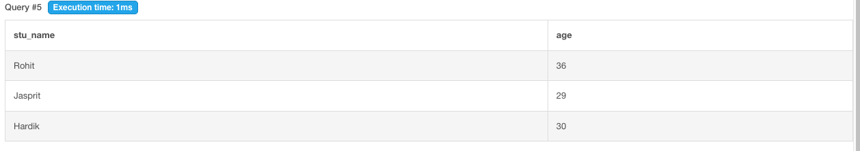

8. Grouping and Calculation

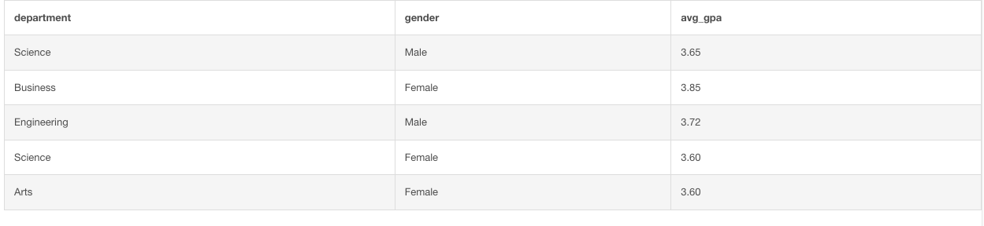

9. Table Renaming



10. Retrieve Student with highest GPA

